Model Trio1000P
Owner Operation and

Maintenance Manual
Field Controls
2630 Airport Road
Kinston, NC 28504
(252) 522-3031
IMPORTANT SAFETY INSTRUCTIONS
Read and save these instructions.
Always unplug the Trio-1000P Portable Air Purification System when it is not in operation, while the Filters or UVC germicidal lamps are being changed, and when cleaning. After servicing this equipment, both the front and top grill assemblies must be reinstalled in exactly the same manner as prior to removal. If either grill is not reinstalled properly, the Trio-1000P Portable Air Purification System will not turn on. This is a built in safety feature.
Before using the Trio-1000P Portable Air Purification System, extend the power cord and inspect for any signs of damage. Do not use the product if the power cord has been damaged.
Warning – This appliance is designed to be used on a flat level surface, and may not work properly on an uneven surface. To reduce the risk of electric shock and injury, do not place in a window. Always place the air purifier at least 12 inches (30.48 centimeters) away from heat sources such as stoves, radiators, or heaters.
Do not move the Trio-1000P Portable Air Purification System while it is in operation. Always unplug prior to moving.
Do not immerse the Portable Air Purification System in water, as permanent damage will occur. Refer to the “Performing Maintenance” section in this owner operation and maintenance manual.

Field Controls Trio-1000P PORTABLE CATALYTIC AIR PURIFICATION SYSTEM FEATURES
Thank you for purchasing a Trio-1000P Portable Air Purification System by Field Controls.
The Portable Air Purification System embodies unique air-purification technologies not found in any other air purifier. The PRO-Cell™ patented catalytic technology signifi-cantly reduces the presence of irritable and toxic airborne gaseous contaminants produced by common household cleaners and materials.
- A quiet, energy-efficient backward-curved impeller that moves 265 cubic feet of air per minute.
- An advanced electronic control system that monitors air quality, air flow and volume, filter and UVC germicidal lamp replacement time.
- A five-stage filtration system with gas-absorption media that absorbs toxic gas, organic hydrocarbons, exhaust fumes, formaldehyde, cleaning chemicals, low level ozone, unpleasant odors, and paint solvents.
- A hospital-grade three-stage HEPA filter removes allergens such as pollen, mold fungal spores, tobacco smoke, insecticide dust, dust mites, and particles down to 0.3 microns (0.00003 inch).
- The PRO-Cell™ photo-catalytic oxidation chamber reduces the spread of airborne disease in the home environment. The powerful UVC germicidal light has 150 times the ultraviolet intensity of bright sunlight, which kills viruses and bacteria on contact.
- Oxygen in the air, combined with photo-catalytic technology and UVC germicidal ultraviolet light, oxidizes airborne impurities too small to be filtered out.
The PRO-Cell™ photo-catalytic oxidation technology, which has received six patents from the USPTO, will keep the air clean and fresh in exactly the same way sunlight and oxygen clean the air we breathe in the outdoor environment.

INSTALLING THE Field Controls Trio-1000P PORTABLE AIR PURIFICATION SYSTEM
CAUTION This product is for indoor use only.
Before unpacking the product, inspect the shipping container for visible damage. If you feel that you may have received the product in a damaged condition, notify the shipper or supplier before opening the container. Remove the product from the box and inspect it for damage.
Handle it carefully. Do not drop!

Place the Purifier in a location that will not restrict air flow through either the air inlet or the air outlet, then plug in the electrical cord at the nearest electrical wall outlet.
NOTE: The Trio-1000P Portable Air Purification System will perform a diagnostic test of indicator lights and functions when plugged in to the wall outlet. This will only happen once, unless the system is unplugged from the wall and reinstalled.
FIGURE 1
!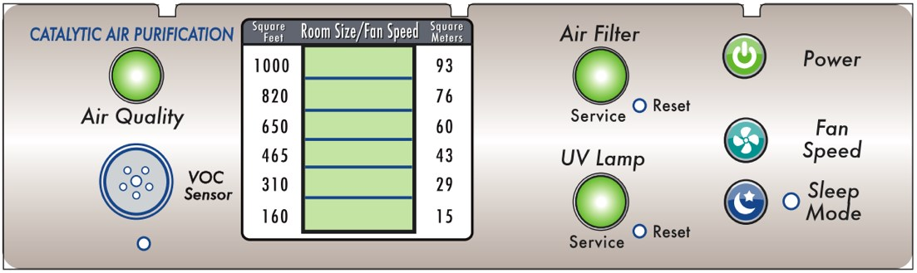
- Press in Power (ON/OFF) button to turn on the Purifier. Lights on the control panel (figure 1) will turn on and the UVC germicidal ultraviolet lamp will be on.
- Look into the air outlet at the top of the Trio-1000P Air Purification System and confirm that the UVC germicidal ultraviolet lamp is on. You will see a faint blue glow when the lamp is on.
When the UVC germicidal ultraviolet lamp is on, the product is ready for operation.
NOTE: The “Air Quality” LED light may turn red on startup until the surrounding air quality improves.
When the air quality LED is red, the air flow is automatically in- creased by (2) power levels. The lowest fan speed cannot be reached until the air quality light turns orange in color, and then green as air quality reaches a safe level.
- Setting the fan speed and air volume to the correct room size.
Press the ”Fan Speed Button” (figure 1) until the green LED bar light underneath ”Room Size/Fan
Speed” reaches the corresponding size of your room. Calculations in both ”square feet” and ”square meters” (length x width) measurements are conveniently listed at either side of the green LED bar lights. Correctly setting this indicator will keep the air volume at an optimum level.
- Press the ”Sleep Mode Button” (figure 1) at night if you desire to reduce fan noise.
A green LED light will illuminate to the right side of the button. This will maintain constant airflow through the purifier and reduce fan speed to a minimum. Since there is no movement in the room, purification requirements are greatly reduced.
Press the Sleep Mode Button again to return to the normal air flow mode.

Monitoring Operation
You can always monitor the air quality of the room.
Air quality is sensed in real time by the chemical-detection sensor (see figure 1) which continually evaluates air quality. Air quality is expressed by one of (3) colors on the air quality LED light.
- Green indicates good air quality.
- Orange indicates poor air quality.
- Red indicates bad air quality.
Air volume is automatically increased by (2) fan speed levels when the air quality indicator turns red, and will reset to a preset fan speed when the air quality indicator turns orange and then green.
It is normal for the air quality indicator to temporarily be red during periods of house cleaning, painting, or cooking meals.
MAINTENANCE OF Trio-1000P Portable Air Purification System
You should also keep an eye on the Service Panel which tells you when maintenance will soon be required.
What the Service Panel Indicator Lights Mean (“Air Filter” and “UV Lamp”)
Indicator lights on the Service Panel tell you if either the air filters or the germicidal ultraviolet lamp will soon need to be cleaned or replaced.
Air Filter Indicator Light:
The filters have a useful life of one year in a typical residential environment.
- Green LED light is On – The filters have been in service for less than 6 months.
- Orange LED light is On – The filters have been in service for more than 5 months.
- Red LED light is On – The filter has been in service for at least 6 months. It is time to remove the front grill and vacuum off the top pre-filter to maintain maximum air flow. The filter does not need to be removed.
Replace the front grill and press only the filter reset button to reset timer for (6) more months. When both the “Air Filter” and “UV Lamp” LED service lights turn red at the same time, filters and UV Lamp have been in service for one year and need to be replaced.
Ultraviolet Lamp Indicator Light:
The UVC Germicidal Ultraviolet Lamp has a useful life of one year (9,000 hours) with a one-month grace period.
- Green LED light is On – The lamp has been in service for less than 12 months.
- Orange LED light is On – The lamp has been in service for more than 11 months. It’s time to order a new UVC Germicidal Ultraviolet Lamp and replacement filter.
- Red LED light is On – The lamp has been in service for more than 12 months. The UVC Germicidal Ultraviolet Lamp may not be effective and must be replaced

Performing Maintenance
Maintenance includes the following procedures:
- Replacing the ultraviolet UVC Germicidal Ultraviolet Lamp.
- Replacing the filters.
Replacing the Germicidal Ultraviolet Lamp
- Unplug the Purifier’s power cord from the electrical outlet.
- Using index fingers, squeeze the locking tabs (figure 6) inwards towards the center of the grill. Lift the grill up and remove.
!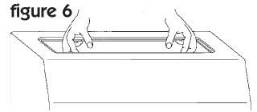
FIGURE
6
- Rotate the Ultraviolet Lamp one-quarter turn, top to rear, (figure 7) and remove lamp.
! 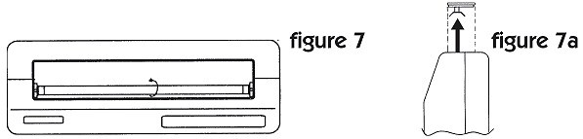
FIGURE
7
FIGURE
7
a
- Insert the new Ultraviolet Lamp in place and install by rotating one-quarter turn (top-to-front).
- Replace the top grill removed in previous step 2 by pressing it into position until it locks. The aluminum reflector must be positioned over the UVC Germicidal Ultraviolet Lamp, nearest the front of the unit (figure 7a).
- Reset Ultraviolet Lamp timer by lightly pressing the related RESET button on the Service Panel (located directly beside the “UV Lamp” LED indicator) with a pin or similar object. The “UV Lamp” LED
service light will turn green, and the 6 month timer will reset. This completes UVC Germicidal Ultraviolet Lamp replacement procedures.
Replacing the Filters:

When both the “Air Filter” and “UV Lamp” LED Indicator lights turn red, both filters and UV lamp have been in service for one year and should be replaced within 30 days.
- Unplug the Purifier’s power cord from the electrical outlet.

- Rest the Purifier on its back (figure 8) to access the bottom of the unit.

! 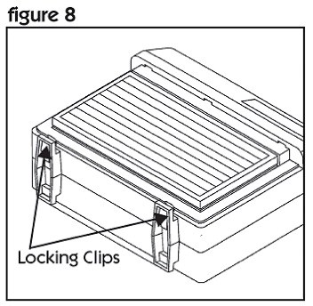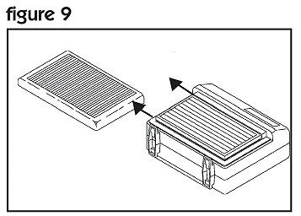!
FIGURE
8
FIGURE
9
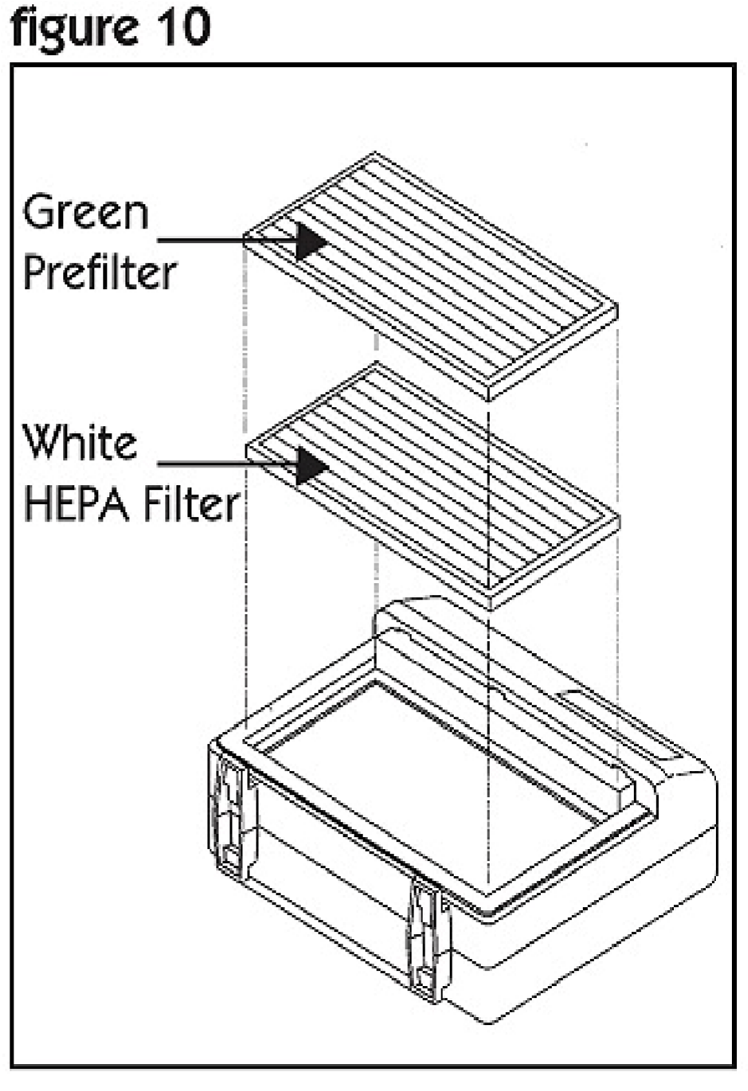
- Press-up on locking clips at the bottom of the front grill.
FIGURE
10
4.Lift bottom of grill upwards, and slide the grill out from the top of the unit. (figure 9)
5.Pull out the two filters individually and discard them.
6.Install new white HEPA filter (labeled second stage) first, with its white layer facing upwards. (figure 10 )
7.Install the new pre-filter (labeled first stage) in the remaining slot, with its white or green side facing upwards.
8.Replace grill. Slide upper end into grill slot and snap the bottom into place until it locks.

Reset the Filter Replacement timer by lightly pressing the RESET button on the Service Panel (located directly beside the “Air Filter” LED indicator) with a pin or similar object. The “Air Filter” LED light will turn green and the timer will be reset. This completes filter replacement procedures.
Restore the Purifier to normal operation as follows:
- Set the unit in its normal operating position.
- Plug the power cord into the wall outlet. Press the “Power” (ON/OFF) switch to operate.
.
 | SPECIFICATIONS
Model | Trio-1000P
Dimensions | 21.5"wide X 18"high X 8" deep
Weight | 23lbs
Maximum Airflow | 265 cfm
Power Consumption | 106 watts, .89 amps
Voltage | 115v / 1ph / 60hz
Blower | Backward-curved motorized impeller - sealed bearings
UVC Germicidal Lamp | 10 watts
Microwatts at surface per cm2 | 16,000
Microwatts at surface per cm2 @ 1ft | 540
UVC Germicidal Wavelength | 254 nanometers
Stage 1 Pre-Filter | 5 micron
Stage 2 HEPA Filter | .30 micron hospital grade
Stage 1 Gas Absorption Layer | Activated Charcoal
Stage 2 Gas Absorption Layer | Activated Charcoal
Application Range | 1000 square feet (auto mode)
Service Interval | 1 Year lamp and filter replacement
Catalyst | TiO2 Anatase
Filter Efficiency % | 99%
Sound Level dBA | 48 to 68
Agency Compliance | ETL, CSA
Warranty | 10 Year Limited Warranty excluding lamp and filters
Limited Warranty
10 Year Limited Warranty
Refer to www.fieldcontrols.com for complete warranty statement.

